**COVID-19 Authorization Letter**

04/02/2021

To whom it may concern

The One Click Solutions Management hereby gives **John Doe – JONDOE001** permission to visit the offices.

Reason: Technical Assistance

Contact: 0641096272

Duration: Until 31/07/2021

Yours Sincerely,

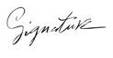

Ammar Canani

CEO One Click Solutions